Syllabus for Specialized English (2 credits)
Students of Nursing

Course books:
- English for the Students of Nursing, by Kashefian et al) 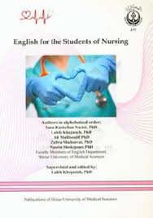
- English for the Students of Nursing, by Kayhani et al. (SAMT Publication)
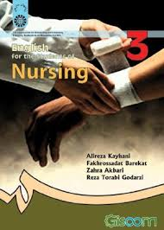
Course aims:
The course is aimed at enabling the students to:
- get familiar with the register and terminologies of nursing;
- develop the ability to read and comprehend domain-specific texts;
- apply reading strategies of skimming, scanning, making predictions, and the like;
- develop the ability to verbalize their comprehension of the texts;
- negotiate ideas and discuss issues related to nursing;
- develop the ability to handle both written and spoken discourse related to nursing.

Course assessment:

- Classroom activities 4 points
(attendance, participation, and quizzes)
- Mid-term exam 6 points

- Final exam 10 points
- The exams include 40-50 items whose major focus is on vocabulary and reading comprehension. In terms of format, matching items, cloze test, and multiple choice items comprise the vocabulary section of the test while the reading section consists of just multiple choice items.

Instructors: Dr. Sjjadi; Dr. Azimi; Dr. Pourhaji; Ms. Amiri; Ms. Malekie

Schedule for Topics and Readings

Weeks | Topics | Source | Page
1 | Introduction
2 | Unit 1  Section 1: Roles and Functions of the Nurse | ONE | 1
3 | Unit 1  Section 2: Nursing Process | ONE | 6
4 | Unit 2  Section 1: Physical Examination | TWO | 16
5 | Unit 2  Section 2: Techniques in Physical Assessment | TWO | 23
6 | Unit 3  Section 1: Health Assessment | TWO | 27
7 | Unit 3  Section 2: Psychosocial History | TWO | 35
8 | Midterm Exam
9 | Unit 4  Section 1: Vital Signs | TWO | 39
10 | Unit 5  Section 1: The Body’s Defenses Against Infection | TWO | 52
11 | Unit 6  Section 1: Wound Healing | TWO | 65
12 | Unit 8  Section 1: Health and Illness | TWO | 90
13 | Unit 10  Section 1: Pain | TWO | 115
14 | Unit 12  Section 1: Perioperative Nursing | TWO | 143
15 | Unit 13  Section 2: Nursing: A Profession for All Seasons | TWO | 166
16 | Final Exam

